Report on Analysis of Koala’s Physical and Biological Characteristics

Bhavesh Hemant Vasnani

Table of Contents
Introduction 3
Section 1: Exploratory Data Analysis and Data Cleansing 3
1.1 Exploratory Data Analysis (EDA) 3
1.2 Replacing missing values 4
1.3 Identifying and correcting wrong entries 4
1.4 Identifying and removing duplicates 5
1.5 Outlier Treatment 5
1.6 Checking distribution and skewness of data 7
Section 2: Data Visualization 8
2.1 Boxplot and Line plot of Chest Circumference (by Gender) 8
2.2 Head Length vs. Skull Width (by Gender) 9
Section 3 : Analysis 9
3.1 Is the mean head length of the Koalas significantly different from 92.0 mm? 9
3.2 Do male and female Koalas have significantly different mean head lengths? 9
3.3 Can we predict the total length of a Koala based on its head length? 10
3.4 Can we predict the total length of a Koala based on multiple factors such as head length, skull width, and foot length? 10
3.5 Do environmental factors such as state affect Koala’s physical characteristics? 11
3.6 What factors are correlated with the total length of a Koala? 12
Section 4: Recommendations 12
References 13

Introduction
The report provides an in-depth analysis of the physical and biological characteristics of Koalas, focusing on gender comparisons, region comparisons and predictive modelling of total length based on a variety of factors. It also explores correlations between environmental and physical characteristics. The main aim of this research is to aid in formulation of conservation strategies for koalas and its implications. The dataset provided to us was cleaned, analysed and visualized using Python, with all relevant code provided in the supplementary Jupyter Notebook. An overview of the business analytics tools and techniques used in the above process is elaborated in the ongoing paragraphs.

Section 1: Exploratory Data Analysis and Data Cleansing
All the necessary libraries needed for data manipulation such as pandas and numpy and data visualization such as matplotlib and seaborn were imported into the Jupyter notebook. This section of the report focuses mainly on exploring and cleaning the data.

1.1 Exploratory Data Analysis (EDA)
The given dataset was loaded into the Jupyter Notebook for analysis using the pandas read_excel() function. A snapshot of the dataset is attached below to get a general understanding of the data and its rows and columns.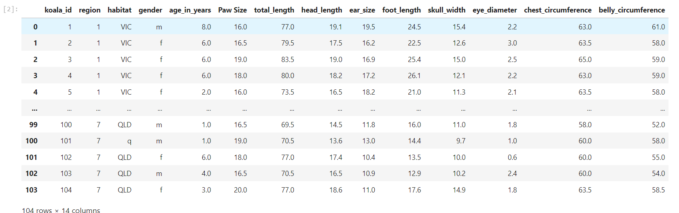
The rows and columns of the data were found using the .shape method of pandas. The table has 104 rows and 14 columns containing various physical and biological characteristics of koalas.
The .info() function of pandas was used to get information about the dataset such as column names, their data types, and null objects in various columns. For example, columns such as koala_id and region have int data type, habitat and gender have object data type (has some textual information) and age_in_years, Paw Size, total_length, head_length, ear_size, foot_length, skull_width, eye_diameter, chest_circumference and belly_circumference have float data type information. The table also showed us that columns such as age_in_years, foot_length, skull_width and belly_circumference.
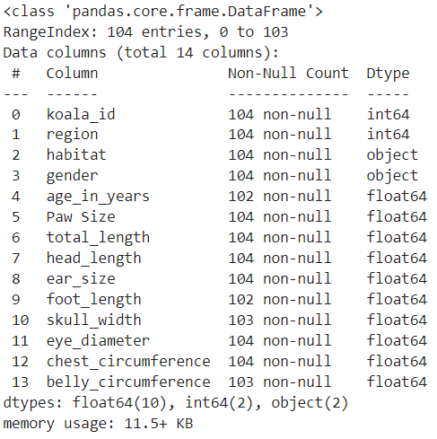

1.2 Replacing missing values
The insights gained from the previous step, gave us a starting point for cleansing the data. The dataset contains some inconsistencies in the form of missing values or NaN values in age_in_years, foot_length, skull_width and belly_circumference.
The number of NA values in each column were re-affirmed using the .isna().sum() function. The above-mentioned script gave the following results.
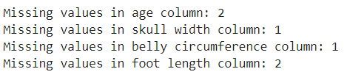
Any missing or NaN values in variables age, skull width, belly circumference and foot length were replaced with the median of the column. Median was chosen for replacement, because it is the only measure of central tendency that captures the centre of the data and it is not affected by outliers. The missing or NaN values were replaced using the .fillna(inplace = True) function. The inplace = True makes sure that all the changes are made in the original data frame. After running the script, the results of the previous code used to find missing values was as follows.
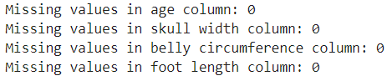
This re-confirms that all NaN values were replaced with their respective medians in the data, to ensure accuracy in subsequent analysis.

1.3 Identifying and correcting wrong entries
All the unique entries in the columns containing categorical data were checked. The unique elements were displayed in the console in the form of a list using the functions .unique().tolist(). The unique elements in the region, habitat and gender column are as follows in respective order.
All the incorrect entries such as 'VICtoria', 'Vic', 'Queensland', 'Queenstown', 'qld', 'q' in Habitat column and 'female', 'male' in gender column were corrected using the .replace() functions and were replaced with their correct spellings. After making the corrections, the code mentioned above gave results like this:

1.4 Identifying and removing duplicates
All the duplicates were filtered out using the koala_id and the .duplicated() functions of pandas. The .duplicated() function was used to return the indexes of duplicate entries and those indexes were used to display the duplicate rows in the console, none showed up. A snapshot of the output data frame is attached below.
This confirms that there are no duplicates in the data frame and therefore no treatment is required for them.

1.5 Outlier Treatment
The boxplot of all the numerical columns were displayed in the console to visualize the presence of outliers in the data frame. The boxplots were plotted using plt.boxplot() function of matlplotlib. A snapshot of all the boxplots is attached below.
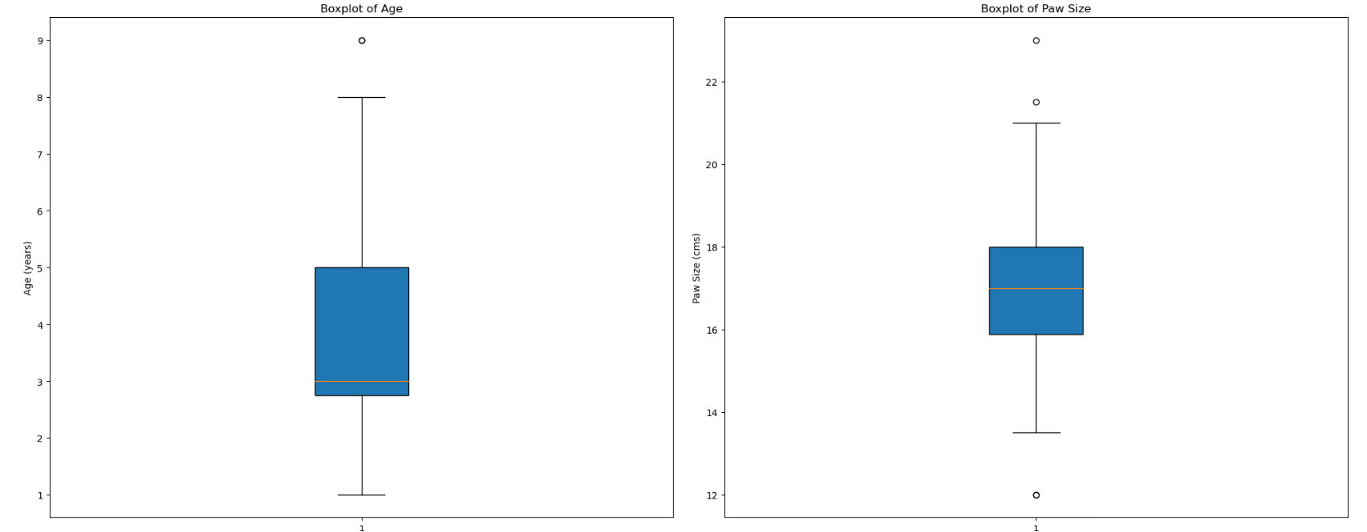
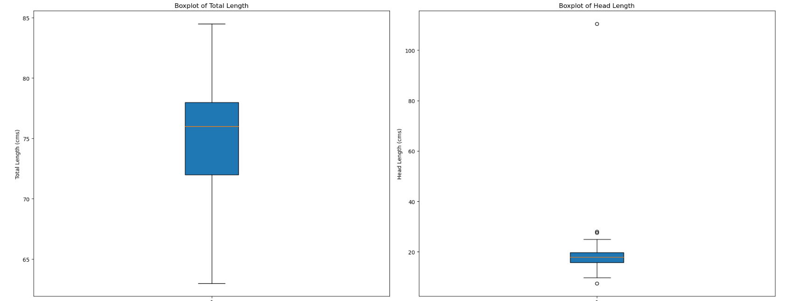
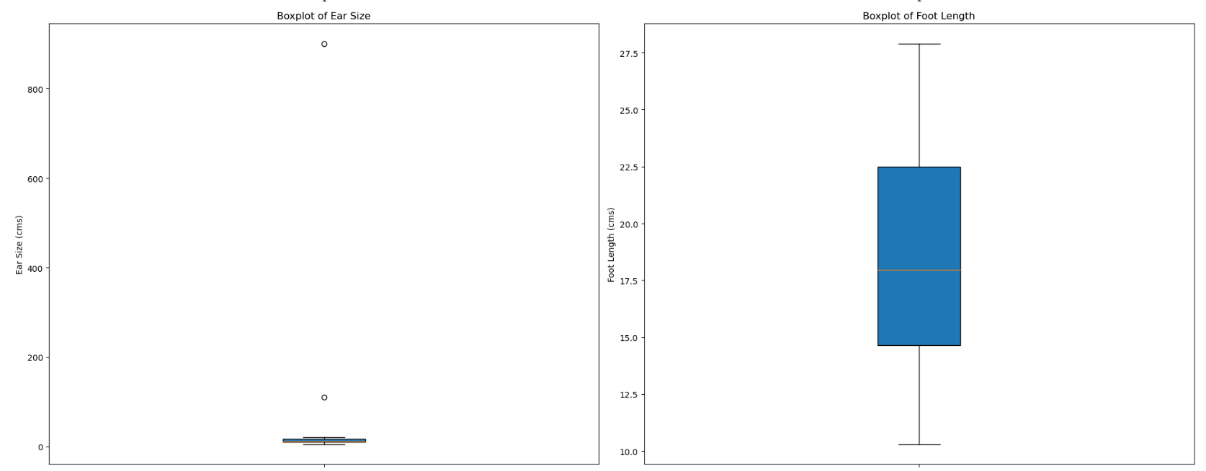
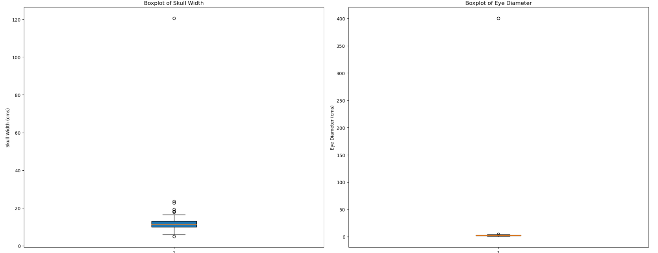
Based on the observations from the boxplot it can be observed that there exist a few outliers in the columns paw size, head length, ear size, skull width, eye diameter, chest circumference and belly circumference. To gain deeper insights into the data, and to make sure that these outliers did not exist in the data due to naturally occurring gender-based differences in koalas, boxplots of all these characteristics was plotted by gender. The boxplots comparing the characteristics in both genders was plotted using sns.boxplot() function of the seaborn library. A snapshot of the boxplot by gender are as follows.
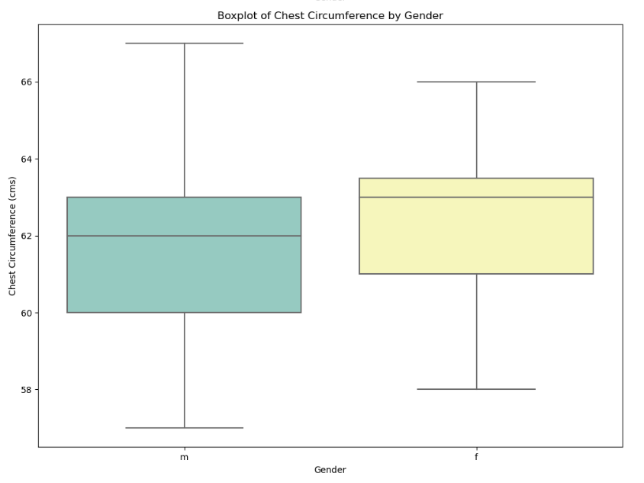
After careful analysis of the boxplot of all physical characteristics by gender, it can be observed that the variations in chest circumference is naturally occurring due to the difference in gender of koalas. Therefore, chest circumference column should not be treated for outliers, so as to maintain the accuracy and authenticity of the data.
All the other columns namely paw size, head length, ear size, skull width, eye diameter and belly circumference were treated for outliers using the Inter-Quartile Range (IQR) method and all the outliers were replaced using the means of the non-outlier data. The .mask() function of pandas was used to create a Boolean mask and the outliers were replaced with the aforementioned mean values. The number of outliers replaced in each column are as follows.

1.6 Checking distribution and skewness of data
Most models rely on the assumption that data should be normally distributed and should not be skewed. To ensure that these assumptions are met during linear regression modelling or multiple linear regression modelling we must verify these assumptions using a histogram and calculating the skewness of the data.
The .hist() function of pandas library was used to display the histogram of all numeric type columns in the data frame. A snapshot of all the histograms is as follows.
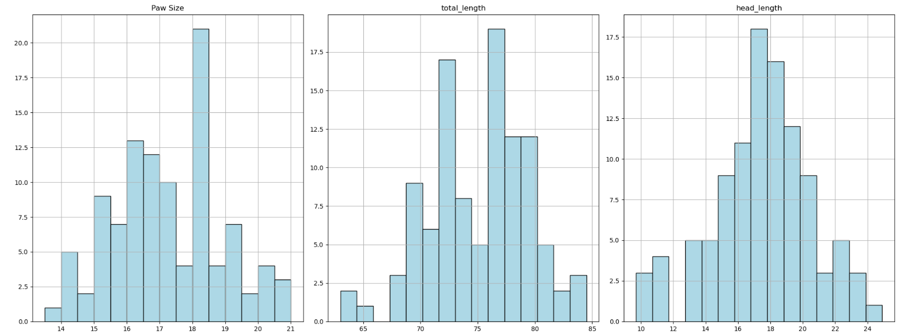
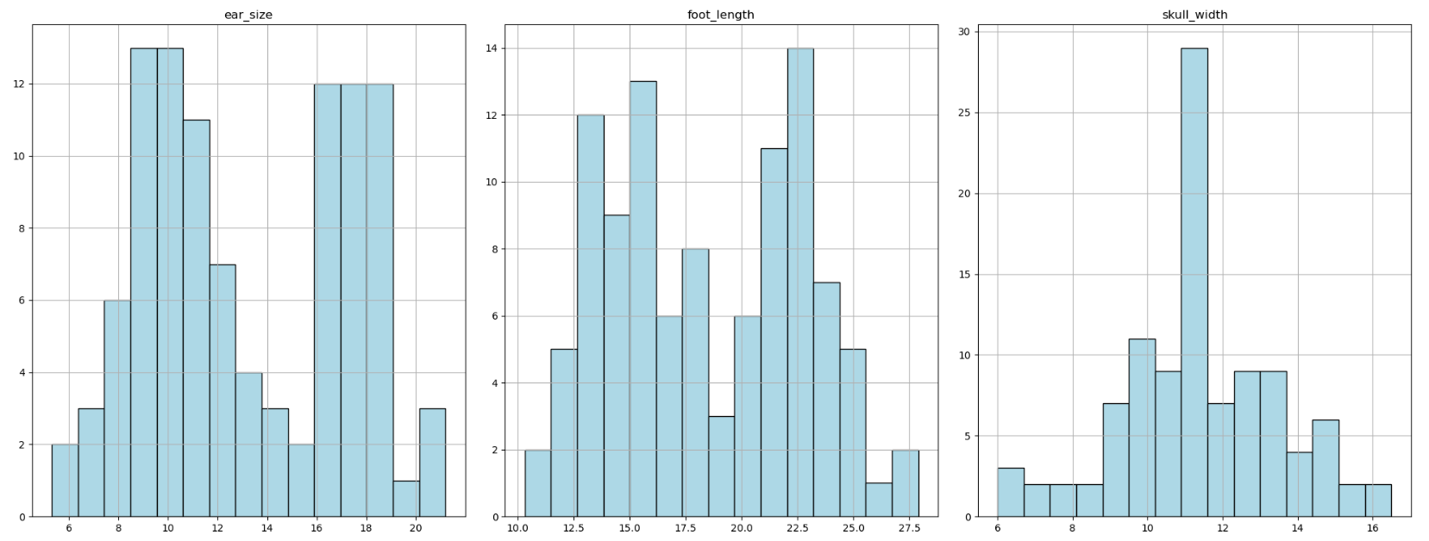
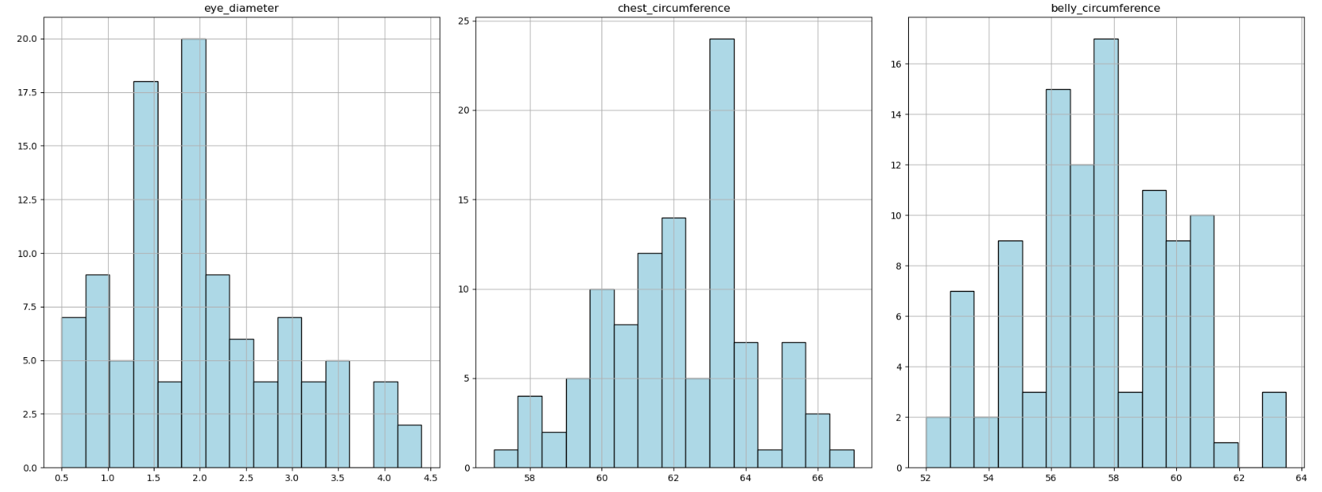
Based on the analysis of the histogram, we can say that region, age, paw size, head length, skull width, eye diameter, chest circumference and belly circumference are normally distributed and total length, ear size and foot length are bimodally distributed. Although, there are no signs of skewness visually.
Skewness can create a bias towards outliers in a statistical model or machine-learning algorithm. All the columns of the data frame were checked for skewness using the .skew() function of pandas. The result of the investigation is as follows.
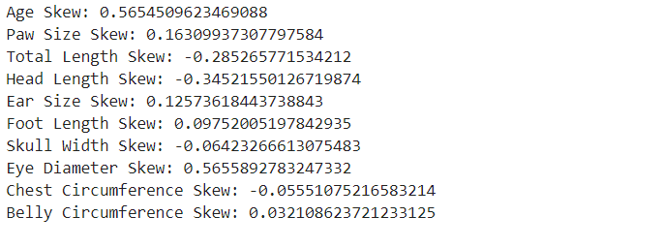
It is very evident that there is no significant skewness in the data, based on the above results. Skewness in the range of -1 to 1 is acceptable and does not warrant a transformation of the data.

Section 2: Data Visualization

2.1 Boxplot and Line plot of Chest Circumference (by Gender)
Male koalas have scent glands on their chest, which can lead to greater chest circumference compared to females (Australian Koala Foundation, 2020). Such speculation is confirmed by the two graphs below.
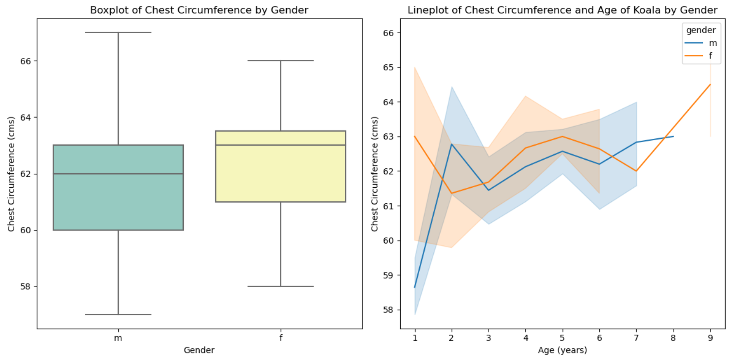
A boxplot visualizes the difference, reveals that males tend to have larger chest circumferences which align with biological expectations. Males showed greater variability and females showed a higher mean. To better understand the data, a line plot was plotted of chest circumference and age with respect to gender. It visualizes that males have smaller chests in the early years, before they grow the scent gland. Then, a sudden rise is seen upon maturity and then it remains constant. Females, have constant chest circumferences with a small rise during the later stages of their lives which justifies the higher means. Therefore, we can surmise that adult males have broader chests than adult females.

2.2 Head Length vs. Skull Width (by Gender)
Male koalas generally have larger skulls to accommodate stronger jaw muscles for their diet and vocalization needs (Australian Koala Foundation, 2020). Graphs below support this statement.
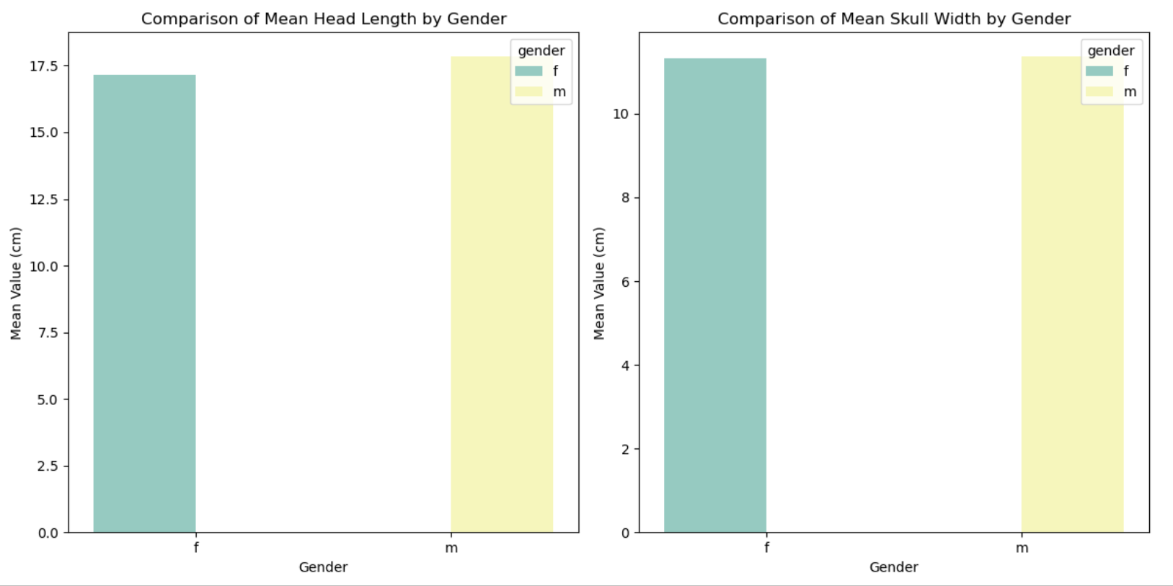
The two bar graphs visualize that males have higher mean head length and skull width. Such an observation is consistent with the biological expectations. Males are generally larger and muscular than females and therefore have higher dietary needs than them. There exists sexual dimorphism in koalas, because males koalas have descended larynx which aids them in making deeper mating calls and bellows establishing dominance.

Section 3 : Analysis

3.1 Is the mean head length of the Koalas significantly different from 92.0 mm?
A one sample t-test was conducted to test whether the mean head length of koala is significantly different from 92.0 mm. The population mean was 9.2 cm, to ensure similar metrics. The null and the alternate hypothesis was formulated. Significance level was decided as 5%. The test was conducted using stats.ttest_1samp() function of stats library from scipy. The test resulted in a t-statistic of 27.82 and a p-value of 1.04e-49, which is much smaller than the alpha level of 0.05. Therefore, we reject the null hypothesis and concluded that the mean head length is significantly different from 92.0 mm. The results of the test are as follows.

3.2 Do male and female Koalas have significantly different mean head lengths?
An independent samples t-test was conducted to compare the mean head lengths of male and female koalas. Two different data frames containing data about male and female koalas were filtered from the koala data frame. The null and the alternate hypothesis was formulated. Significance level was decided as 5%. The test was conducted using stats.ttest_ind() function of stats library from scipy. The test resulted in a t-statistic of 1.15 and a p-value of 0.251, which is much larger than the alpha level of 0.05. Therefore, we cannot reject the null hypothesis and concluded that there is no statistically significant difference between the mean head length of male and female koalas. The results of the test are as follows.

3.3 Can we predict the total length of a Koala based on its head length?
A simple linear regression analysis was performed using head length as the predictor for total length. Total length was the dependent variable and head length was the independent variable. The model was fitted to the data using ols.fit() function of ols library of statsmodels.formula.api. The formula derived from the linear regression analysis is as follows.
Regression Formula:
y (total_length) = 59.43 + 0.8917 * x (head_length)
The model yields a positive correlation, indicating that head length is a good predictor of total length. The model has an R-squared value of 0.402, suggesting that approximately 40.2% of the variability in total length can be explained by head length. The F-statistic tests whether the overall model is statistically significant. A very low p-value indicates that the model is highly significant. P-value close to 0, indicates that head length is statistically significant in predicting total length. The results of the model summary are as follows.
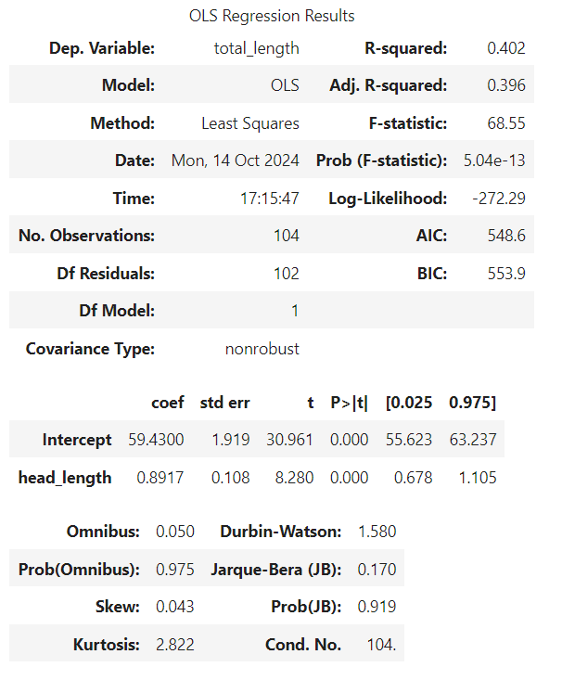

3.4 Can we predict the total length of a Koala based on multiple factors such as head length, skull width, and foot length?
A multiple linear regression model was constructed using head length, skull width and foot length (independent variables) as predictor for total length (dependent variables). A variable x was created which included all the independent variables and a variable y which included the dependent variable. The model was fitted to the data using sm.OLS(y, X).fit() function of statsmodels.api. The formula derived from the linear regression analysis is as follows.
Regression Formula:
y (total_length) = 1.8723 * x1 (head_length) + 2.1344 * x2 (skull_width) + 0.9057 * x3 (foot_length)
The p-value of all the independent variables is close to 0, indicating that all independent variables are statistically significant in determining total length. The F-statistic tests whether the overall model is statistically significant. A very low p-value indicates that the model is highly significant. The model produced a R-squared value of 0.986, indicating that these factors collectively explain 98.6% of the variability in total length, making this a more robust model than head length alone. The results of the model summary are as follows.
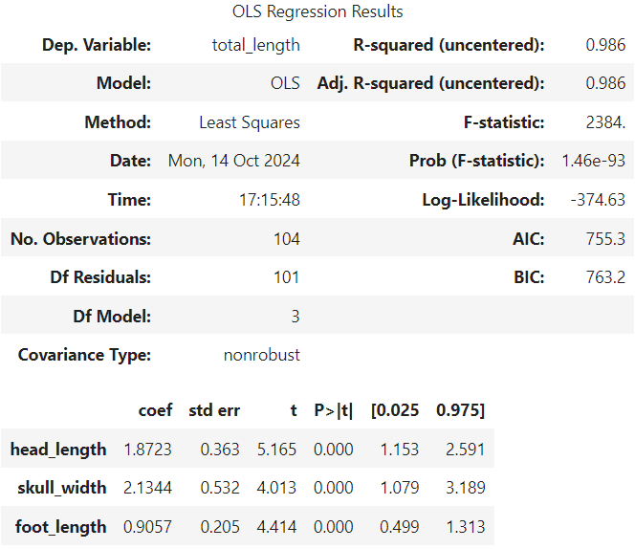

3.5 Do environmental factors such as state affect Koala’s physical characteristics?
The categorical variable habitat was converted into numbers using one-hot encoding method. The first column was dropped to avoid the dummy trap in our analysis. The Boolean data type was converted into int data type for ease of analysis. The resulting data frame from the one-hot encoding process is as follows.
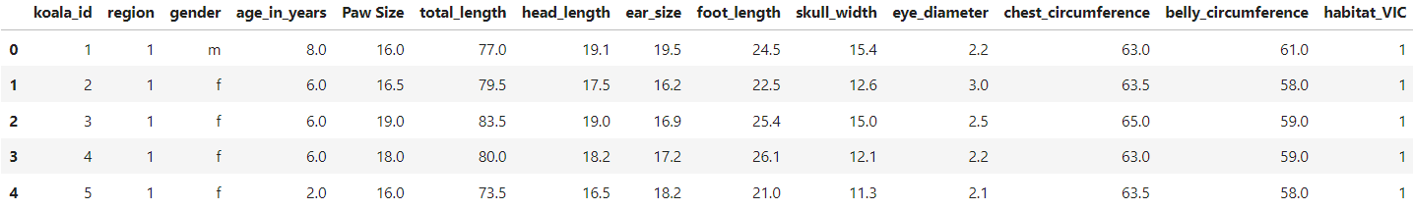
A correlation matrix was generated, showing some strong positive correlation between habitat and physical characteristics such as ear size, foot length and negative correlation with paw size. On the other hand, a strong negative correlation was shown between region and physical characteristics such as chest circumference, ear size and foot length and positive correlation with paw size. This acts as conclusive proof that there exists relationship between environmental factors such as state and region and koala’s physical characteristics. Two heatmaps were used to visualize the correlation between koala’s physical characteristics and state or region. The visualizations are as follows.
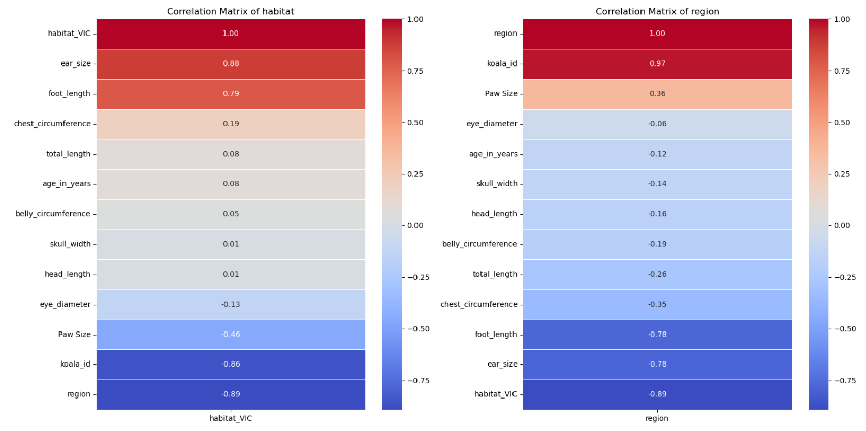
To further check the accuracy, a two-sample t-test was conducted to see if there is a difference between the physical characteristics of koalas in both states, that is, QLD and VIC. The test found that the difference in mean of paw size, ear size and foot length between the two states is statistically significant. The results of the tests are as follows.
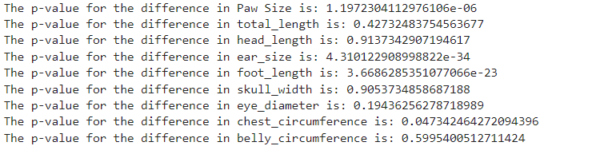

3.6 What factors are correlated with the total length of a Koala?
A correlation matrix was generated, showing strong positive correlations between total length and head length, skull width, chest circumference, foot length and paw size. These physical traits are positively correlated with total length, reinforcing their importance in predicting the overall size of a koala. A multiple linear regression model with a high R-squared value can be trained using these characteristics. A heatmap was used to visualize the correlation between total length and other physical and biological characteristics of a koala which is as follows.
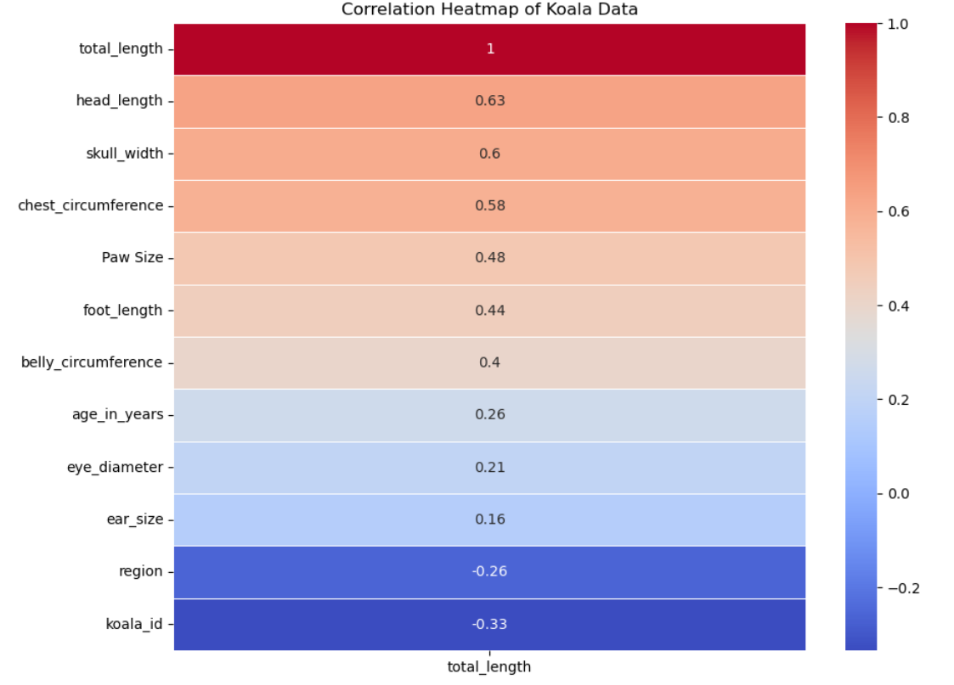

Section 4: Recommendations
The findings of this study provide valuable insights for formulating conservation strategies. The significant difference in physical characteristics between regions highlight the need for region-specific conservation strategies. The significant difference in physical characteristics and needs of male and female koalas should also be considered while formulating such policies and should be focused towards catering their gender specific needs. For example, male koala’s large chest circumference and head size should be considered while evaluating habitat needs, as these traits influence social behaviours and vocalization. Conservation strategies should focus on protecting diverse habitats to support koalas’ physical and biological needs, including their dietary requirements and mating behaviours.
Protecting the environmental diversity in koala habitats across regions (such as Queensland and Victoria) will ensure that population remains healthy and adaptable. Moreover, managing environmental threats like deforestation is crucial for sustaining koalas’ physical health and ensuring the preservation of their unique biological traits. This report has made great findings about the physical and biological characteristics of koalas based on their state and gender which may aid in the conservation effort. Although, the analysis done in this report suffered from major drawbacks such as limited availability of data and introduction of bias in the data. Further research is required and may build on the contents of this report.

References
Australian Koala Foundation. (2020). Physical characteristics of the koala. Save the Koala. https://www.savethekoala.com/about-koalas/physical-characteristics-koala/

